A Capsule Wardrobe in 8 Easy Steps

Step 1: Select Your Base Color (navy or black)
Select a base color, an easy one like Navy or Black. I always start with either navy or black because those colors are easy to build around. Black goes with almost every color, so that one is most common. If you’re not much into black, then select navy. Navy is especially popular in the spring and summer months.

Step 2: Add 2 Bottoms In Your Base Color
Next, add 2 different bottoms in your base color, like a skirt, pants, dress or shorts. You might choose 2 items such as black pants and a black skirt or a navy skirt and navy dress.

Step 3: Add 3 “Essential” Tops/Bottoms
What are “essentials”? They are the pieces you reach for time and time again, like a white tee, white button-up shirt, gray tee, denim, chambray etc. When choosing these pieces, focus on white, gray, denim, chambray or your base color, like black or navy. Since these are neutral pieces and colors, you won’t grow tired of them. Add three tops and/or bottoms.

Step 4: Choose Your Accent Color
An accent color can be a color such as coral/peach, red, pink, tan/cream, blue, olive, teal or even gray as a neutral accent color. This is the color that will “stand out” and add color to your wardrobe. Be sure that your accent color goes well with your base color. You will finish building your capsule wardrobe around your base and accent color.
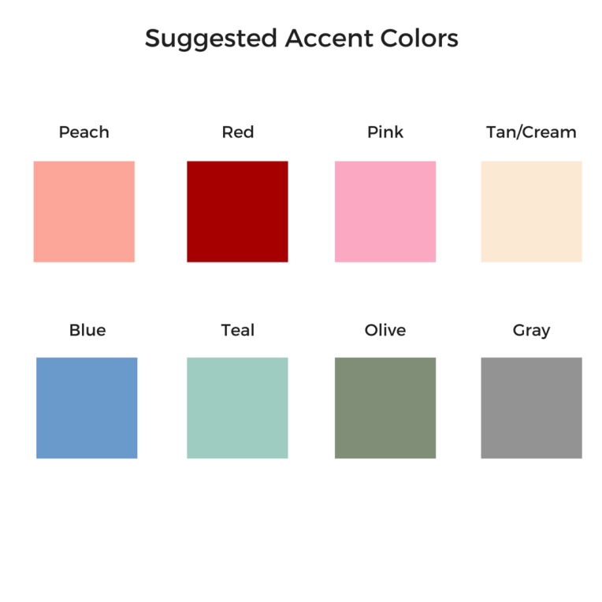

Step 5: Add a Patterned Top
When you have a capsule wardrobe, it’s best to limit your patterned items to 1 or 2. Choose patterns that are always in style, like stripes or small patterns like dots or gingham. Stripes are always popular! Also, be sure that your pattern matches your base color.
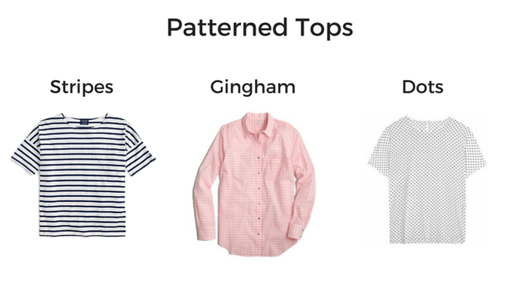

Step 6: Add a Bottom In Your Accent Color
Choose a bottom like a skirt, pants, dress or shorts in your accent color. Make sure it coordinates well with at least half of your items so far.

Step 7: Add Layers
Add 1 or 2 layering pieces, like a utility jacket, blazer, denim vest, cardigan, denim jacket or coat. In the summer months when it’s the hottest, a denim vest or lightweight sleeveless vest can add interest to an outfit while still staying cool.
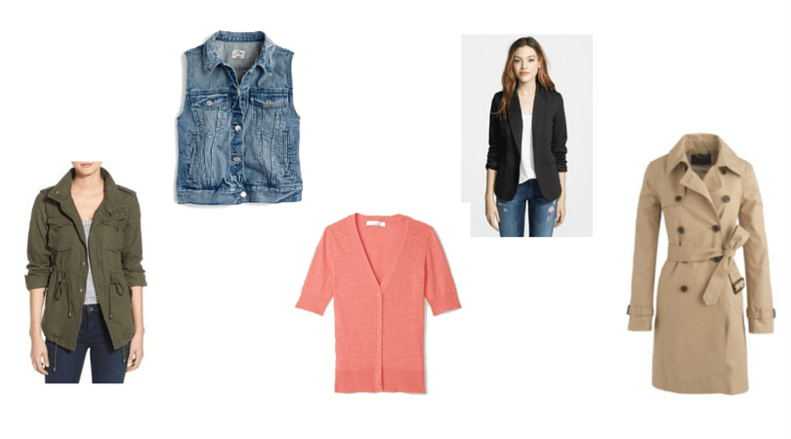

Step 8: Add Shoes
Choose 3 or 4 pairs of shoes that will coordinate with your clothes. Suggested shoes are: sandals or boots, sneakers, heels or flats. You want to choose that fit all types of occasions: shopping, work and events. 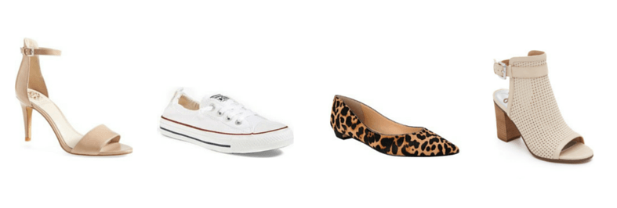
You can keep adding tops and bottoms to keep building your capsule wardrobe. Limit your items to 29 or less for an efficient capsule wardrobe. When you are finishing creating your wardrobe, you can add your accessories like jewelry, scarves and handbags. Have fun with your capsule wardrobe!

Information Source: http://classyyettrendy.com/2016/06/create-capsule-wardrobe.html/

